I. Matlab compiler runtime 2015a is required prior to installing HistoView:

<https://drive.google.com/file/d/0B8ZdVjH4QtuyU1VRbDV0elJoQTg/view?usp=sharing>

II. Download HistoView 3.12:

<https://drive.google.com/open?id=0B8ZdVjH4QtuyRzJBWjNXc3N4U3M>

III. Open HistoView, click “Annotation” button:

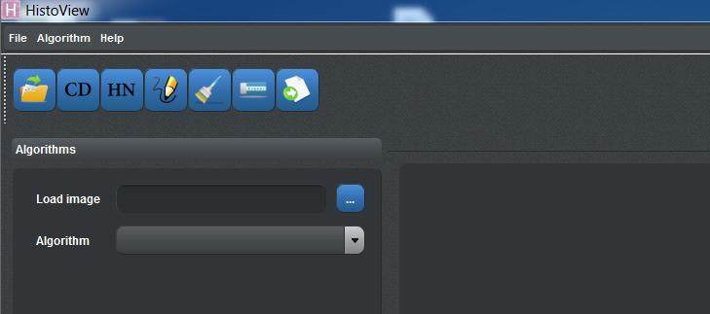

IV. Annotation window will open, select File->Open to open a new image.

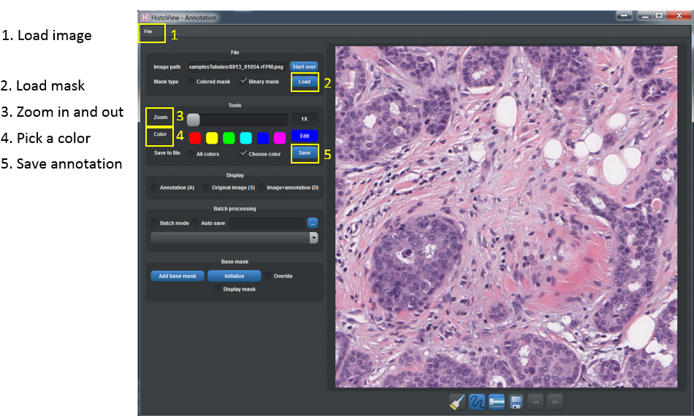

Some tips:

1. To load an image, select File->Open and choose an image in tif, png or jpg format.

2. To load a recently opened image, click “File” and select the target image from the recent files list under “Save”.

3. To load a binary mask, check “Binary mask” and click “Load”.

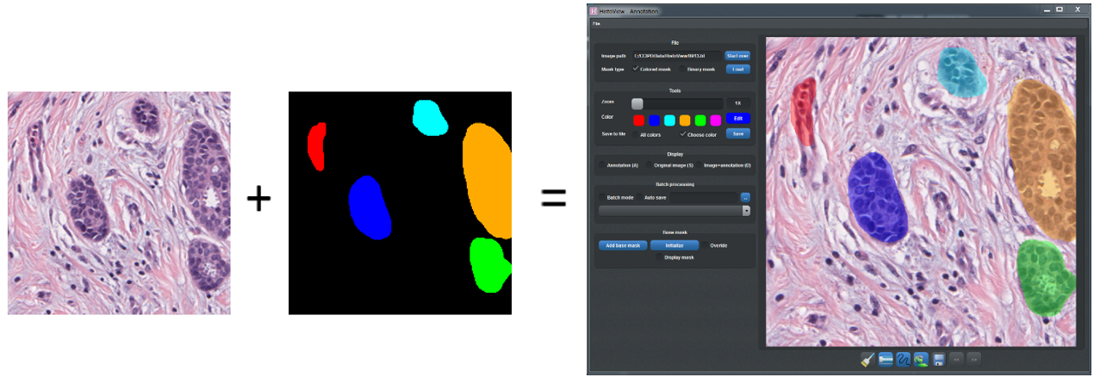4. To load a colored mask, check “Colored mask” and click “Load”.

5. Move the “zoom” slider to zoom in and out.

6. Pick a color from the six default colors or click “Edit” to select a specific color.

7. Hold “Ctrl” key and scroll wheel up to zoom in; hold “Ctrl” and scroll wheel down to zoom out.

8. Click the paintbrush/eraser/freehand/regionfill buttons or press Z/X/C/V to switch between four modes.

9. To block out a large region, use the freehand tool to create a boundary, then switch to regionfill mode and click any point inside the region to fill the ROI.

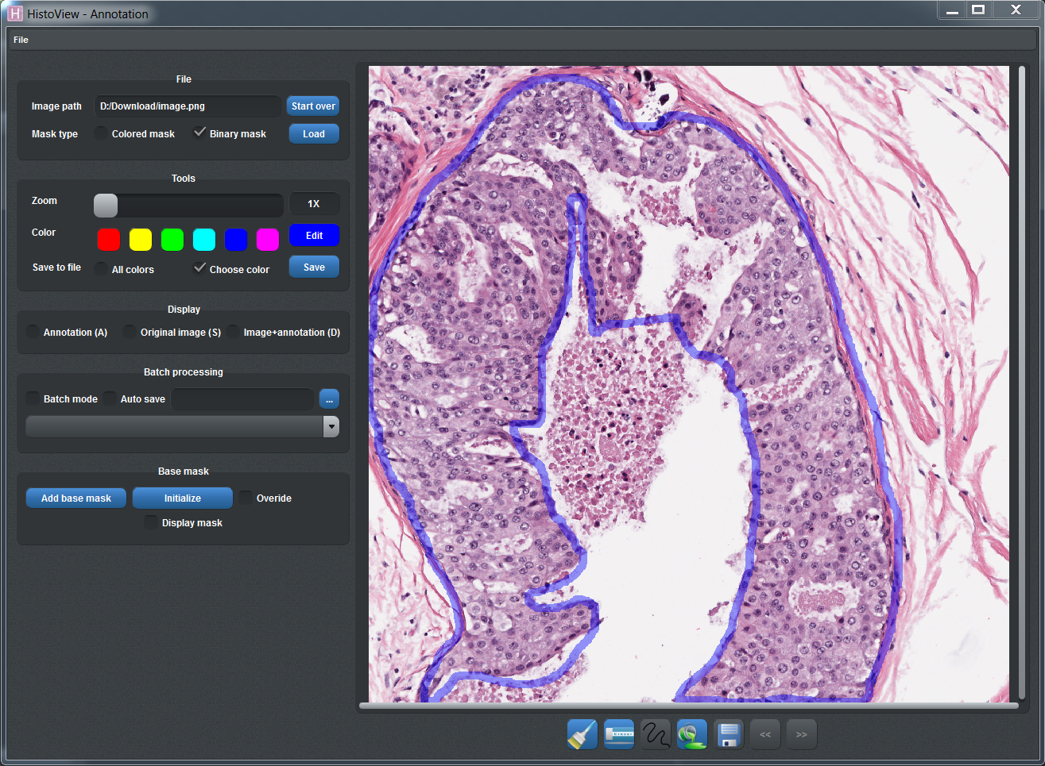 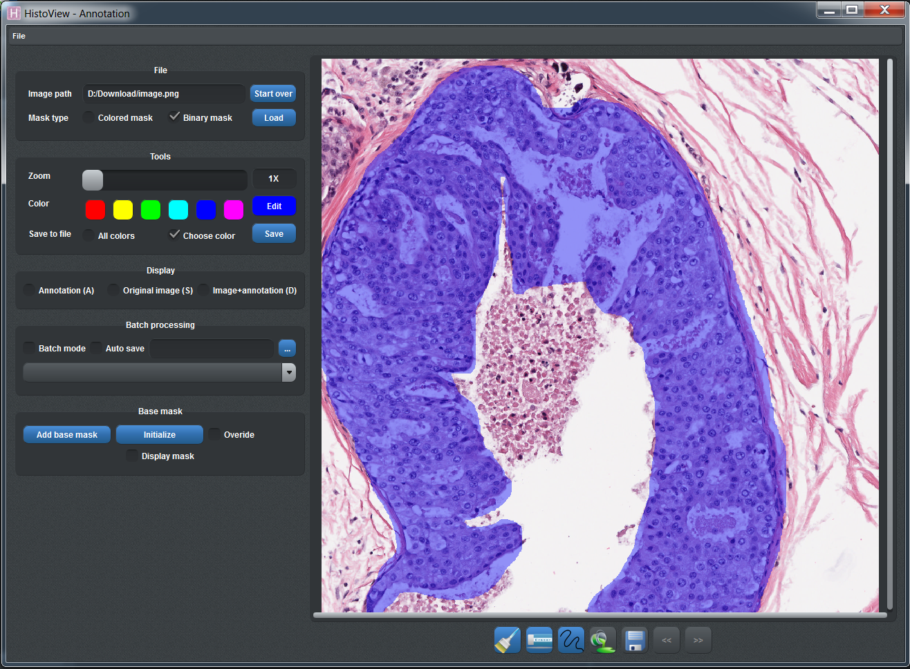

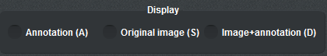10. Check “Annotation (A)” or press A to view annotation mask only; check “Original image (S)” or press S to view original image; check “Image+annotation (D)” to view annotation on top of original image (the default view).

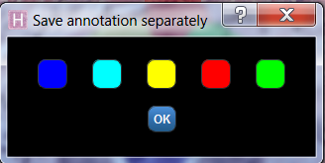11. To save annotation click “Save” button or press “Ctrl+S”.

Check “All colors” to save all the annotations in different colors or check “Choose color” and pick one color of annotation to save a binary mask.